  - BASS Controls enhances school district with help of S4 Open: BACnet: N2 Router

Customer Location
Lake Orion Community Schools is a school district headquartered in Lake Orion, Michigan that attracts students from the Village of Lake Orion, Orion Township, and small parts of Oxford Township, Oakland Township, and Independence Township. This award-winning public school district educates 8,000 students within 12 public school buildings.

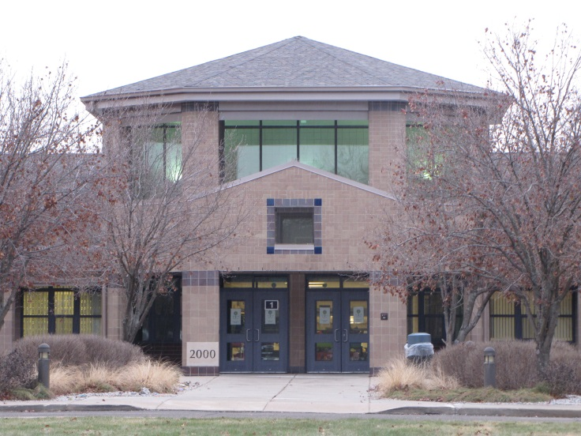
Customer Needs
The District has a Johnson Controls Metasys® system that is slowly being replaced by American Auto-Matrix (AAM) AspectFT Technology. However, it is both cost-prohibitive and logistically impossible to make this transition all at once.
The customer sought a cost effective way for their existing Metasys® System to report alarms to the facilities department via email notification to improve their building management capabilities until the complete transition to AspectFT can be completed.
There were concerns about the cost of this upgrade since it was intended to be a short term solution until the transition to the new AAM system could be completed. There were also concerns with minimizing any interruptions to classroom utilization and other instructional activities. With this in mind, a performance specification was written for a project to monitor and alarm the districts walk-in coolers and freezers in seven of the schools.

Solution
BASS was able to win the competitive bid for the project using S4 Open: BACnet-N2 Router technology which allows the BACnet open protocol AAM system to integrate to the proprietary Johnson Metasys® N2 system. By using S4 technology, the work was focused at the head end of the Metasys® system, meeting the goal of minimizing (or, in this case, eliminating) any impact on classrooms and educational activities. After the S4 Open: BACnet-N2 Router network appliance was inserted into the Metasys® system, the built-in configuration wizard was used to discover all N2 devices, the applications in those devices, and publish the associated points to BACnet/IP. These new features are transparent to the legacy Metasys® system and required no reprogramming of the Metasys® system. From the standpoint of the Metasys® system, it was business as usual. BASS Vice President, Steve Yelle, stated “No other solution considered could provide the capabilities of the S4 Open: BACnet-N2 Router. In addition to the technical capabilities, this solution met the financial goals of the project.”
The devices to be monitored were located in different buildings, and on different Metasys systems, throughout the school district. However, all Metasys systems were connected by a common Metasys N1 supervisory network. With BASS’s deep knowledge of Metasys, they were able to write a GPL program in one of the NCMs that had visibility to all NCMs in the district. That program gathers the readings from all locations and writes them to a N2 controller on its local N2 bus. The S4 Open: BACnet-N2 Router associated with this N2 bus publishes the gathered data to BACnet/IP.
This innovative approach allows for JCI N2 point values (freezer/cooler temperature values) from the remaining JCI Metasys system to be accessed by the new American Auto-Matrix AspectFT Enterprise server as if they were BACnet devices and points. The AAM server polls the S4 device for cooler/freezer temperature values and generates an alarm should a temperature rise above its programmable alarm limit. The AAM system determines and reports alarms to the facility management department via email message. Since the initial project, the system has been expanded to include monitoring and alarming of the boiler hot water heating loop.
Wes Goodman, Executive Director of Operations

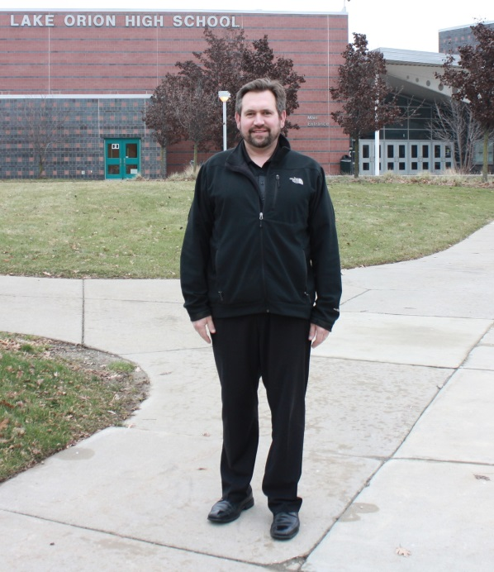
Customer Satisfaction
The Lake Orion Community School System is pleased with the results of the S4 Open: BACnet-N2 router installation. Wes Goodman, Executive Director of Operations at the school commented on the success of the project: “We are very satisfied with this solution. It was not only the most economical approach, but the monitoring of these critical systems has also mitigated loss and damage and provides us a sense of security that our systems are monitored."

About Building Automation Systems and Services (BASS)
Building Automated Systems and Services (BASS) is a full service, independent temperature controls and building automation systems contractor located in Sterling Heights, Michigan. Their website is www.basscontrols.com and you can contact them via email at info@basscontrols.com or by calling (586) 731-0793.

